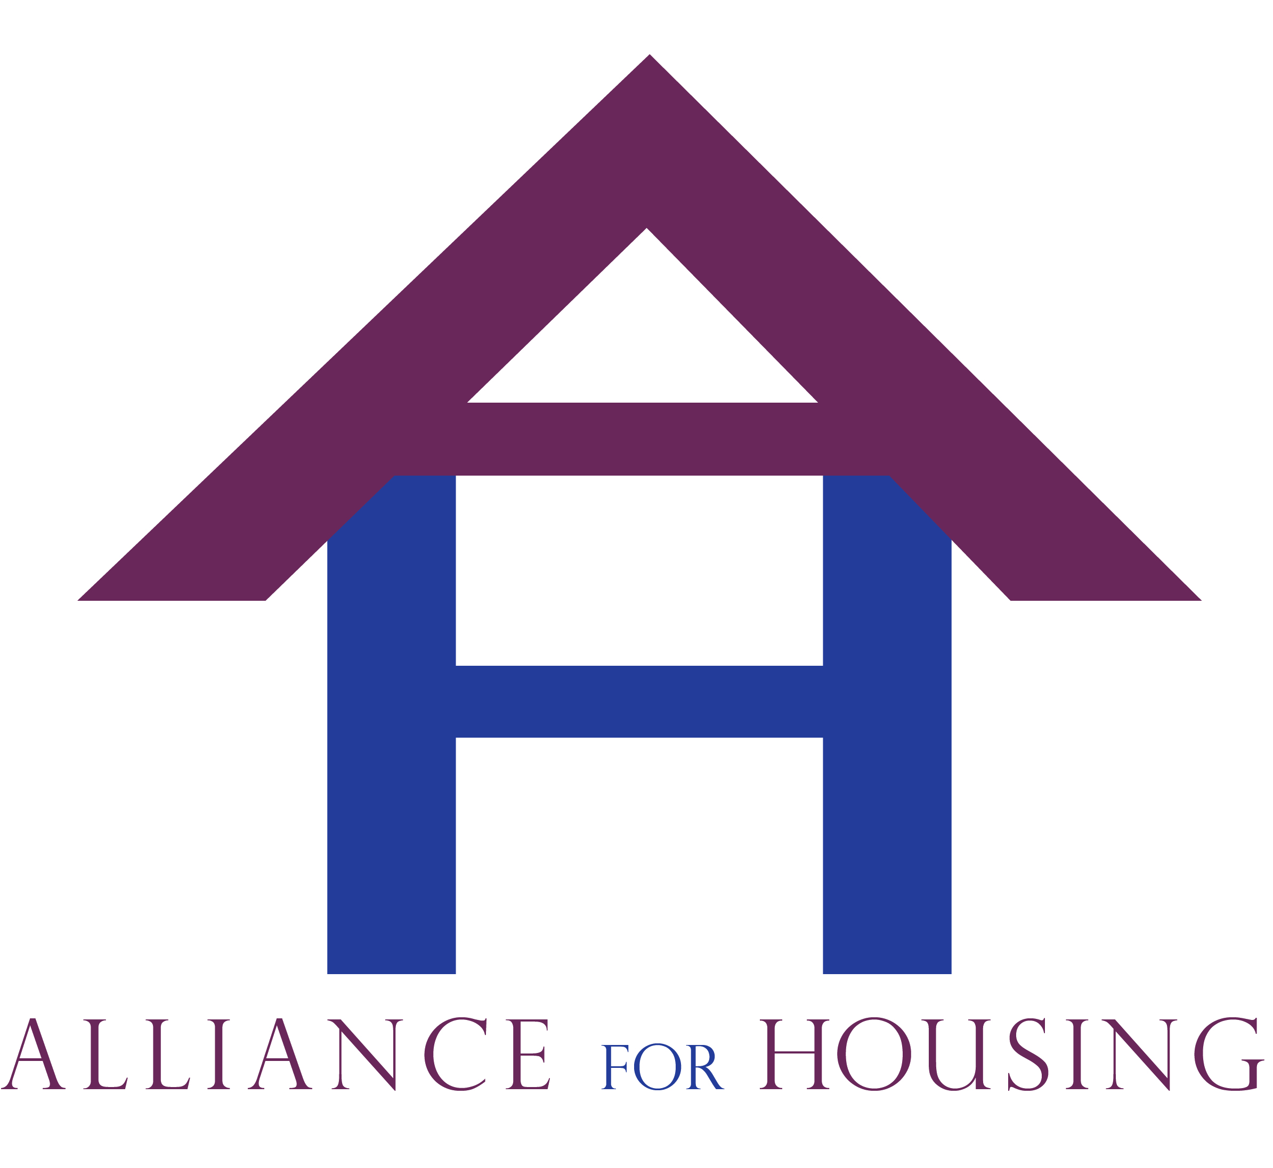
Alliance for Housing
Bi-monthly General Membership Meeting; Tuesday, November 18, 2014
Meeting Minutes - Respectfully submitted by Daniel Kelly
Attendance: Leah Mccall (Alliance), Jill Shoemaker (HMIS), Ernestine McCrae (HAVEN), Rachel Mitton (SOS), Liz Lucas (OLHSA), Monica Wafford (HOPE), Bev Weir (Oakland Health), Rachel Densmore (CMH), Gloria Lutey (Oakland Health), Deb Hendren (CHN), Sue Benson (Oakland Schools), Bonnie Littleton (VA), Dawn Pischel (CHN), Jessica Mumma (CHN), Heather Zimmerman (MPRI), Jason Morgan (SOCH), Kevin Bogg (TTI), Dan Kelly (SOS), Sarah Sprony (Common Ground), Sharman Davenport (Lighthouse), Ebonne Clark (Easter Seals), Ecole Brooks (OCCMHA), Jamie Christofel (CHN)
Introductions
Meeting was called to order at 1:37pm.
Leah called for introductions.
Leah asked if there were any additions to the agenda. Leah noted she would like to complete a presentation to go with the outcomes committee update. The agenda for the general membership meeting was approved. Marc Craig motioned and Liz Lucas seconded approving the minutes from the September general membership meeting.
Announcements
Sarah Sprony reported that Jim Perlaki was no longer working with Common Ground.
Presentation
Jason Morgan of the Welcome Inn presented. He gave a presentation on the Welcome Inn. He noted the origin of the Welcome Inn was after a person died on the street in Royal Oak. He noted that the South Oakland Citizens for the homeless and the South Oakland Warming Center are two different organizations that work together. The goal of the South Oakland Citizens for the Homeless is to create day time programs to assist those experiencing homelessness in Oakland County. SOCH would like to provide basic services to its guests and then link them with extensive programs from other agencies. They have a case manager who will be working 35 hours a week. They would like to create a wrap around of services for those in the welcome inn. The Welcome Inn opens in December 2014. He noted the overnight, South Oakland Warming Centers opens December 15th. He noted the Welcome Inn daytime center opens at that same time. He explained that they have as many 80 people in the welcome inn each day. He noted SOCH is located at Starr Presbyterian Church in Royal Oak (13 Mile Rd., and Crooks Rd.). The website is: sochwi.org. To reach Jason Morgan, the Executive Director: Jason@sochwi.org, 248-636-2484.
Bev Wier presented on the work of the Oakland County Health Department. She noted they are doing extensive outreach to meet the health needs of clients in local shelters. She noted they are working to sign people up for Michigan Medicaid and other services. She noted her goal is to link those experiencing homelessness with health care services. She also noted she works with the local hospitals to aid homeless households with finding housing after being discharged from the hospital.
Committee and Workgroup Reports
Board Report
Marc Craig reported. He noted the HUD COC application was successfully submitted. He noted the Board now has DNO liability insurance as well. He also noted that they are in the process of procuring general liability insurance for the Alliance for Housing. Marc proposed electing two additional Board members; Deb Brinson of the Oakland Integrated Health Network (OIHN) and Rachel Densmore from CMH. He noted Ms. Brinson is very interested in homeless health care and has even submitted grant funding for homeless health care. Marc Craig nominated Ms. Brinson, Ernestine McCrae seconded her. The motioned was approved unanimously. Marc nominated Rachel Densmore and Ernestine McCrae seconded the motion. The motion was approved unanimously.
Marc noted that attendance at the Board meetings has been sparse. He noted that a new attendance policy has been approved by the Board; he asked if there were any questions regarding this new attendance policy with the general membership.
Marc also noted that Jim Perlaki was elected as the treasurer of the Alliance Board. Marc noted that even though Jim Perlaki is no longer being employed at Common Ground, he would like for him to continue his role as treasurer until a new replacement is found. Marc asked if anyone else would like to step into the role and begin training for it. His goal is to have Jim in the role for a short period while a new person is trained and on-boarded into the role. There were no comments.
Operations
Leah Mccall presented. She noted that the HUD COC application was successfully submitted. She noted that the group was working to incorporate the zero to 2016 campaign. Leah noted that the Zero to 2016 campaign. She explained that this campaign is an extension of the 100,000 homes campaign. She noted that the Alliance was approved to participate.
Systems Coordination & Implementation
Deb Hendren presented. She noted that the PSH registry is going well. She noted that the registry is working in conjunction with the Moving Up Voucher program to prioritize those with the highest need into housing programs in the community. She noted the group meets each week over the phone and once a month in person to conduct disposition on names on the PSH registry and link them to open PSH units and other housing assistance in the community. She noted that the group is putting those with a VI Spdat of an 8 or higher on the registry.
Gloria Lutey presented on the newly formed transportation taskforce. She noted the group is going to work on meeting the transportation barriers of those served. She noted that the group has had the transportation ombudsmen from Smart Transportation to come to their last meeting.
She noted there is a pilot program going into effect with local Secretary of State offices with regards to Michigan IDs. She noted the Alliance ID taskforce has worked on this extensively. This will allow those experiencing homelessness to receive IDs with the aid of a homeless services partners when they are lacking certain required documentation. She noted that people with no income cannot have the ID fee waived; however those that have low income can get it waived.
Dan Kelly reported on Community Resource Day. He noted that the event is Wednesday, November 19th from 10:00am – 4:00pm at Trinity Missionary Baptist Church, 123 Wesson St., Pontiac, MI. He thanked the Community Resource Day planning committee for all their hard work. He noted that any attending agencies should come to the event between 9-10am that morning to set-up. He noted the extremely wide array of services that will be present at the event and is looking forward to a successful event. He asked that if anyone has any questions they can contact him on the number he provided via the vendor email he sent out 11/17.
Ernestine McCrae reported on the Affordable Housing Committee. She noted the group is working to develop relationships with housing developers to ensure they build sustainable housing developments in the committee. She noted that the group is also trying to educate the local community on the need and positive impact of the affordable housing. She noted that they wish to become a “development ready” community. Marc noted that the group is working on creating guiding principles for developers.
Finance & Audit
There was no presentation. Marc Craig noted that the Alliance has utilized almost all of their funds to support their operations until receiving a draw-down from LOCCS. He noted that the organization conducted a draw down in the last few weeks successfully.
Advocacy & Public Awareness
Leah Mccall presented. She noted they are working extensively on the community resource day event. She noted there are video and audio PSA. She noted that there is a calendar up on the website that notes upcoming Alliance related events. She noted there were press releases that went out for Community Resource Day.
Project Monitoring and Performance Outcomes (HMIS)
Jill noted that a Community Performance Outcomes Plan (CPOP) has been created. The outcomes committee worked on this document to track ongoing outcomes for the community. She noted the group is still tweaking this document on an ongoing basis. She noted the Board had approved an initial plan. She noted the goal is to have the CPOP available on the website eventually. The committee meets the second Monday of each month at 10:00am; location to be determined.
Region 10 Report
Leah Mccall reported. She noted the group discussed that youth programs are not to use the VI Spdat for youth services. She noted HOPE hospitality is having a vigil tonight for homeless awareness week.
HARA Single Point of Entry Report/Update
Jamie Christofel reported. She noted the homeless preference voucher recertification process went well. She noted that there are 140 people currently on the wait-list. She noted that there will be another pull of another 100 people in the next three weeks. She stated they really want to populate the waitlist so that they don’t move over to the general voucher waitlist. Populating names on the homeless preference voucher waitlist is thus extremely important. Jamie noted that every 120 days individuals on the homeless preference voucher list must re-certify their literal homelessness.
She noted there are also still vacancies at Spring Lake Village for project based vouchers. She noted they can fast track any applications for this project-based development.
Deb Hendren presented on updates for the HARA and ESG. She distributed a program overview grid that she stated should be maintained internally by agency case managers and not given to clients. She noted all the programs in the County to assist homeless and at-risk communities.
Deb noted that the Landlord Breakfast was conducted last week and was extremely successful. She noted that the event had over 80 attendees.
Deb reported on the happenings of the ESG program at Community Housing Network. Dan Kelly reported on the happenings of the ESG program at South Oakland Shelter. Deb and Dan noted the programs are still in operation and noted the referral processes. She asked that anyone serving a person who is interested and may qualify for ESG, they should send an HMIS referral for ESG services and/or submit a paper referral to SOS. Also, if anyone serving a client has any questions, they should contact Deb or Dan to discuss.
Point in Time
Leah Mccall noted the committee did meet in November and is currently planning for the event. She noted that the PIT count date is January 28th, 2015. She noted they are still seeking a site in the South end of the County. She asked that if anyone is interested in the joining the committee or the related sub-committees, please contact Leah Mccall. Leah noted she will be sending out to the listserv the sub-committee information for those interested in joining.
The meeting was adjourned at 3:02. Next meeting is at the County Executive Building, 4th Floor.

